FCM Asia blog -Business travel outlook for Asia in 2020
Business travel is amongst the first casualties of economic, political and environmental uncertainty – whether regionally or globally. As the world enters the third decade of the 21st century, the trade war between the U.S. and China is just one looming threat.
IATA estimates that, should the economic conflict between the two nations escalate, passenger movement could fall by up to 68 million globally. Add to this possible recession in the U.S. economy, the impact of instability in the Middle East on oil prices and the specter of inflation, and the global outlook for 2020 is based around a slowing in the pace of global growth price rises across air, hotel and ground transportation.
World’s fastest growing business travel market
Against this background, the Asia Pacific region remains the fastest growing business travel market. Driven by China, India, and the emerging economies of Southeast Asia, business travel spending is predicted to more than double to $900 billion by 2025 – more than half of the global total.
Asian business travel spends by country - 2005-2023
Source: Amadeus, Oxford Economics
Within the region, corporate travel spending is swinging away from traditional markets like Australia, Japan, Hong Kong and Singapore to emerging markets like China, India, Indonesia, Thailand, Malaysia and the Philippines.
China is the continent’s largest source market, with international travel up by 9% during the first nine months of 2019 compared to 4.5% by North Americans. By 2025, China will become the world’s largest corporate travel market, spending $500 billion by 2025 – roughly twice what they do now.
This is even more impressive considering that the number of Chinese visitors to the U.S. fell as China’s Ministry of Culture and Tourism advised against travel to the U.S., and business trips by Chinese government employees were severely limited in response to U.S. tariffs on Chinese imports.
India’s business travel market is worth $25 billion corporate travel market and is expected to more than double to $60 billion by 2025.
The range of industries in Asia continues to diversify, with financial services and mining rapidly growing sectors alongside the more traditional agriculture, electronics and infrastructure. This growth and diversification are driving business travel volumes across the region, with many organizations reviewing and re-thinking their travel programs to take full advantage of a rapidly expanding market.
Air
LCC seat capacity – Asia Pacific 2008 - 2018
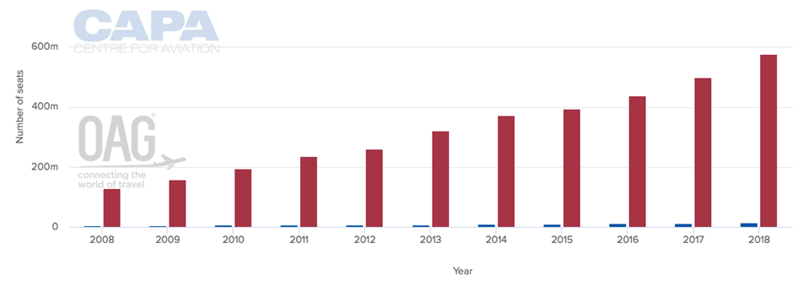
Source: CAPA
Let’s start with the bad news. The crude oil dispute between the US, China and Iran could disrupt oil flows. In particular, the U.S. has implemented sanctions against Iran, and China is defying them. Although strong competition and connections can enable airlines to resist price rises, the collapse of India-based Jet Airways has led to higher airfares.
The slowdown in China’s economy prompted Chinese airlines to slow domestic capacity growth from 12% during 2018 to 8.4% during the first five months of 2019 as well as adopting a more cautious approach to network expansion. The major carriers are taking contrasting approaches to their products. China Southern is majoring on larger economy cabin whilst China Eastern is targeting business class travelers.
The region’s airport capacity is growing. The new Daxing International Airport will relieve pressure on Beijing Capital International Airport, whilst Airport Authority Hong Kong is investing $18 billion to up-grade its airport. One hundred new airports will open in India over the next twenty years, taking the country’s number of operational airports to 200 by 2040.
Low-cost carriers (LCCs) are now well-established in Asia, driven by increased competition that continues to produce some low business fares – and lower yields for the airlines. In an already heavily populated Asian LCC market, the 2,000-strong Southeast Asian fleet has nearly as many aircraft on order - mostly from LCCs.
LCCs dominate domestic air travel in India, are growing in other domestic and regional markets and are gaining traction amongst Asian business travelers. In the five main domestic markets (Indonesia, Thailand, Vietnam, Malaysia and the Philippines), LCCs account for at least 50% of the capacity. LCCs account for more than 70% of the domestic market in Thailand and nearly 70% in the Philippines.
All five countries have large domestic markets of at least 25 million annual passengers. Combined these five domestic markets generate over 220 million annual passengers, led by Indonesia with around 100 million.
However, the increased capacity driven by the LCCs comes at a time when businesses are becoming more careful about travel – although there’s no sign yet of more supply and less demand leading to lower air fares.
In fact, industry predictions are for regional fares to rise by 3% for business class and 2% for economy fares overall across Asia, compared to intercontinental fare rise predictions of 1% for both business and economy travel.
The biggest rises in the region are set top occur in Indonesia (7.9%), Australia (5.1%) and China (4.4%).
Asia Pacific air fares 2020
Source: GBTA
Advice for travel mangers
- Focus on total ticket cost rather than the base fare and encourage travelers to trade down to economy where possible and book off-peak flights.
- Consider new carriers but remember that in some countries LCC fares are no cheaper than full-service airlines once the extras are taken into consideration.
- Create a culture of getting travelers to book early to reduce the impact of rising fares
- Be realistic on market share and don’t dilute your preferred carrier programme – it will affect your agreements
Hotel
Asia is experiencing an unprecedented hotel development boom. Investment in the region’s hospitality industry will grow by 15% on the next twelve months as international brands open alongside local hotels and corporates include more independent properties in their programs.
Excluding China, the region has 958 projects under construction that will add 221,927 hotel rooms that will open in 2020. Having opened 338 new hotels during 2019. As the country prepares to host the 2020 Olympics, Japan has the largest pipeline with 41% of all new hotels in 2019 and 30% in 2020.
Other countries with significant pipelines include Indonesia (375 new projects, 21% of Asia Pacific’s total), India (236 projects), Vietnam (134) and Malaysia (also 134). City-wise, Jakarta, Indonesia has 84 in the pipeline, followed by Seoul, South Korea with 73 and Kuala Lumpur, Malaysia with 54 projects. Tokyo has 53 projects and Bangkok 46. 41% of the region’s pipeline is being fulfilled by Marriott International 258 projects), AccorHotels (218), InterContinental Hotels Group (162) and Hilton (91).
The China hotel market is expected to be worth US$ 136 billion by the end of 2023. With political and social stability, rapid economic growth and a vast population base, China has inevitably attracted the world's leading hotel chains.
There are 1,062 projects in the Chinese hotel pipeline which, once completed, will grow the country’s inventory to 256,506 bedrooms. 55% of these projects will open by the end of 2020; Hilton is leading the way with 40 projects and 11,272 rooms currently under development, followed by Four Points by Sheraton with 38 projects and 10,016 rooms. The world’s largest hotel group, Marriott International, has 35 projects and 8,770 rooms coming to China.
Whilst international visitors prefer upmarket brands, more mid-priced and economy products, plus lifestyle or boutique properties aimed at millennial guests means that Asian travel buyers can meet their company’s financial needs and those of their travelers without diluting their buying power.
OYO (On Your Own) Rooms exemplifies the Asian hotel market. Now just six years old, OYO is now the world’s fastest-growing hotel group, with 23,000 hotels in 18 countries - mainly in Asia. Ranked the globe’s sixth-largest hotel chain, OYO is backed by more than $1 billion in funding from investors including Airbnb.
OYO currently has more available rooms in China than in its home market of India. In 2020, OYO will be investing US$50 million in new hotels in Vietnam as it aims to grow to 20,000 rooms in ten Vietnamese cities.
Asia hotel rates growth 2020
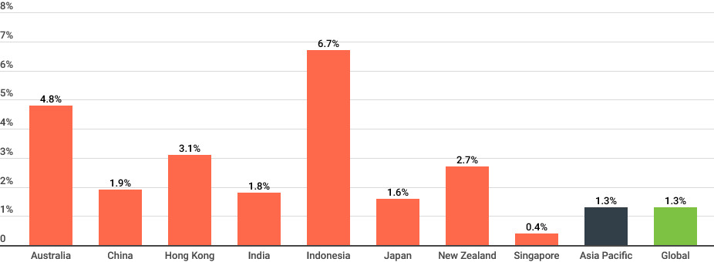
Although room supply is growing, hotel rates are set to rise by between 1% and 4% during 2020. Bangkok, Ho Chi Minh City, Kuala Lumpur, Melbourne, Shanghai and Singapore are expected to see a 2% rise, compared to 1% in Beijing and Sydney. Hong Kong is set to see a rise of 3% due to record visitor numbers driving occupancy and the rate of hotel development slowing into 2020.
Advice for travel mangers
- Focus on total cost of stay – using a hotel further from the meeting location might be cheaper but travel costs may erode the savings and waste travelers’ time.
- Consider using independently owned local hotels in places where the chain hotel rate is high.
- Reduce negotiated rates by excluding amenities un-used by travelers.
- Talk to your TMC about new hotels opening – especially Asian brands.
Ground transport
Ground transport pricing 2020
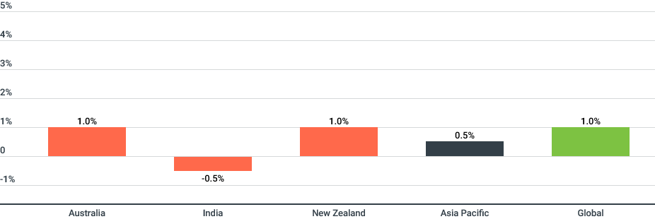
Source: GBTA
Ground transport in Asia may be dominated by high-speed rail, but ride-hailing is becoming a popular alternative to traditional taxis due to the comparative savings, price transparency and convenience.
Although ride sharing has not traditionally been included in corporate travel programs, 2019 research found that most organizations in Asia are receptive. In Singapore, Japan, Australia and Hong Kong, 87 - 89% of travel managers allow their travelers to use ride-sharing services, compared to 80% in China and 79% in India.
Uber has yet to take the same dominant position in the Asian market as it has elsewhere. China’s biggest player is Didi Chuxing, whilst Grab is the preferred option in most of Southeast Asia having bought out Uber locally. Gojek leads in Singapore, Thailand and Vietnam and is looking to enter Malaysia.
in Japan, taxis are traditionally supported by the government. However, with visitor numbers set to soar for the 2020 Olympic Games and other events, nationwide ban on ride sharing has been partially lifted. However, a ban remains on shirotaku cabs that use private automobiles to charge passengers for their ride, which includes Uber.
High-speed rail is a popular alternative to air travel in China, being cheaper and more reliable. China has built 23,914km of high-speed rail lines since 2008 and is expected to reach 30,000km by 2020 and more than 80,000km by 2035.
The new Beijing - Qingdao line has cut journey times from five to three hours, compared to a ninety-minute flight. Government-controlled rail fares are rising to fund network expansion, but electronic ticketing will soon be introduced.
In Japan, up to 70% of domestic business trips are made by train, with the Tokaido Shinkansen highspeed service between Tokyo, Osaka and Nagoya the most popular. Thailand plans to introduce high-speed lines from Bangkok to Thailand’s northern border with Laos and between Don Mueang, Suvarnabhumi and U-Tapao airports.
A massive new rail hub is being constructed in Bang Sue which will replace the 103-year-old Hualamphong Station in Bangkok. The new station in the city’s northern suburbs will serve the new high-speed network as well as the existing rail services, which are currently being upgraded from single to dual track around the country. The Thai government is planning to move around 10% of flights from Suvarnabhumi to an upgraded U-Tapao to reduce pressure on the over-capacity BKK airport.
Their goal is to improve access to the Eastern Economic Corridor, a zone that comprises 80% of total overseas investment in Thailand and is the country’s flagship economic project. The three-airport/EEC high speed rail links are also expected to reduce pressure on the road network and cut travel times by more than half.
India is beginning to build high-speed rail lines, although the Mumbai-Ahmedabad bullet train service is not scheduled for completion before 2023. However, the Singapore-Kuala Lumpur line is planned for opening in 2020.
Overall recommendations for 2020
- Stay abreast of the general and market-specific landscape to understand supplier expectations and optimize the value from these relationships.
- Work with your TMC to forecast spend variations and be receptive to using all types of hotel agreement after analysing your hotel spend, market by market.
- Prioritize airlines able to provide high quality WiFi at a reasonable price. Your travelers need to make the most out of their travel time.
- Review travel policy as new rail routes are added and mandate rail when fares and total journey times are as good as, or better than air. Where the network exists, high speed rail is comfortable, reliable and punctual.

Amadeus - Business Travel in Asia Paciﬁc: Setting the Smart Course
https://www.htrends.com/trends-detail-sid-108421.html
https://hoteldesigns.net/industry-news/500-new-hotels-slated-to-arrive-in-china-by-2020/
Hotel Monitor 2020
International Union of Railways

